|  |  |  |
| --- | --- | --- |
| Teacher: Ms. Nyentap  Students: 20-25 (Grades 9-12) | Equipment: Small flat cones, 5 jump rope, Q-cards numbered 1-50 in 3 colours, print-outs for the wall (coloured paper), tape, 4 Blue Matts, 8 ab matts, wooden boxes, dumbbells (lightest to 20 lbs), kettlebells, medicine balls (all), benches (3), 10 hurdles, 2 chairs, tires, cones to mark out zones. | Date: November 21, 2018 |
| Lesson Segment | **Task** | **R-Ques** |
| Warm-up (5 Minutes) | * Jogging * Dynamic Stretching |  |
| Main Set (40-45 Minutes) | * Get into your squads from this morning and stand on the blue matts * Introduction of main objectives  1. SWBT identify the 5 components of physical fitness 2. Include some exercises learned today into “toolbox” so that they may better these areas in the future  * Explain Rules of the game (*see p. 2*) * Manage game and location of players | * Form during exercise * Teamwork and encouragement |
| Cool Down/ Debrief (5 Minutes) | * Static stretching * Discussion of 5 components of physical fitness/ identify each station as part of one of the 5 | * 5 Components of Physical Fitness |
| Homework (2 Minutes) | * Assign to everyone but the winning team: Students are to take what they have learned today (exercises belonging to the 5 components of physical fitness) and come up with 1 exercise per component. They must submit it via video format of total group doing it. |  |

***Note.*** This lesson will need significant set-up time.

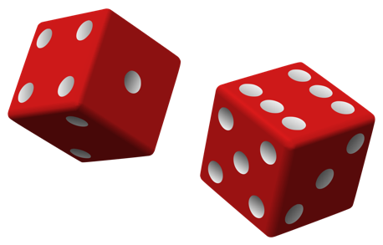

## **Rules**

1. Each team has one dice.
2. This dice will also serve as your player in the game.
3. One team member is to roll the dice. The number it lands on is the number of spaces you can advance forward. In the cone, you will find a Q-card.
4. Show the Q-Card to the teacher (me). I have a coding sheet for the colour of the Q-card, as well as a tally sheet for the amount of times you’ve gotten that colour. Based on these factors, I will send you to the designated station.

For example, let’s say you roll a 5 and inside cone 5 there is a yellow card. Yellow = station 1, 2, 3. I will send you to either station. On the wall of the station you will have fitness tasks to perform. You must complete the tasks as a team (not one before the other, all together, encourage and help each other out) and once everyone is done, come back to your matt.

1. If students did it properly, without cheating, they may roll again to advance their piece and repeat this process. If they get the same colour Q-card, they may go back to the same station (and I will give variations that make it harder), or they will be send to another station not occupied by a team.
2. If two students land on the same cone HOLD GAME, they go into the challenge zone. They may pick 1 team to join them, and one to join the opposing team (so whole class is participating).
3. On teacher’s signal they go in pairs through the obstacle. First team to make it through gets to advance their dice forward __ spaces (a free roll), then roll again to determine their next fitness station. They also get to send the losing team to a station of choice. This team will not be allowed to advance their “player” until they have successfully completed this.
4. The only way to get in the challenge zone is if your piece lands on another teams, or if you’re trying your best at the stations and showing good team effort, I may award you a challenge zone.
5. The objective is to get to the end of the game board first. First team to do this, wins and gets out of tonight’s homework assignment.

## **Gym Floor Diagram**

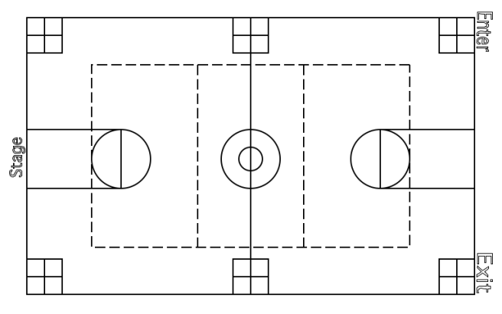

Start

Finish

## **Station 1: Muscular Endurance**

## 

|  |  |
| --- | --- |
| 1st time here: 1 Minute Jump Rope  2nd time here: 1.5 Minutes Jump rope | Image result for jump rope |
| 1st time here: 45 Second Plank (From Elbow position to Hands)  2nd time here: 1 Minute Plank (From Elbow position to Hands) | Image result for plank from elbow to hand |
| 1st time here: 20 Body Weight Squats with Jump  2nd Time here: 1 Minute Body weight squats with jump | Image result for muscular endurance circuit |
| 1st time here: 10 Burpees  2nd time here: 1 Minute burpees | Related image |
| 1st time here: 1 Minute step ups  2nd time here: 1 Minute step ups (as fast as you can) | Related image |

## Station 2: Muscular Endurance

1st time here: 30 seconds flexed arm hang **or** as many chin ups as possible in 1 minute (may be assisted)

2nd time here: 45 seconds flexed arm hang **or** as many chin ups as possible in 1 minute (may be assisted)

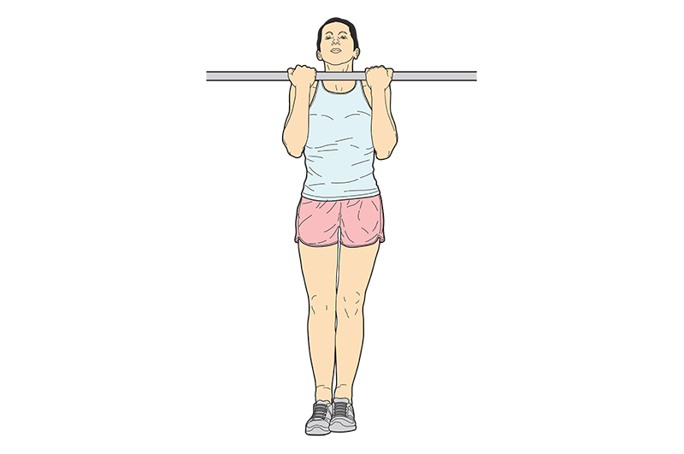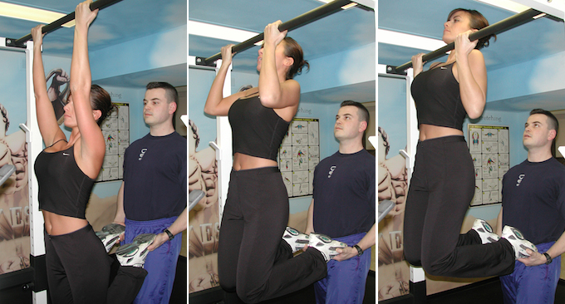

1st time here: 20 Jumping Jacks

2nd time here: 40 jumping jacks

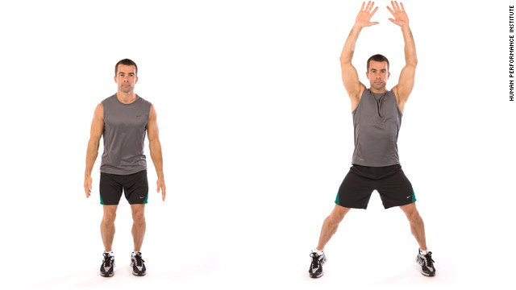

1st time here: 60 seconds wall sit

2nd time here: 60 seconds wall sit with weight on top

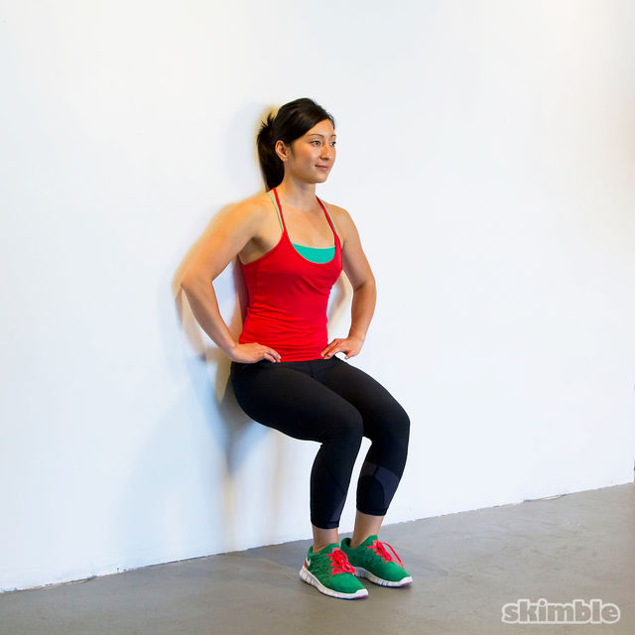

## Station 3: Muscualr Endurance

1st time here: 30 Seconds Rope Slams

2nd time here: 45 seconds rope slams



1st time here: 30 seconds side Plank (Each Side)

2nd time here: 45 seconds side plank (each side)

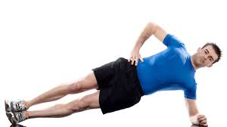

1st time here: 30 seconds Incline push-ups (using chair or boxes)

2nd time here: Same task, however, if you used the box incline the other way (like the chair) to make it harder.

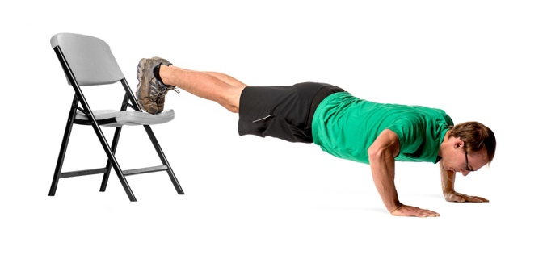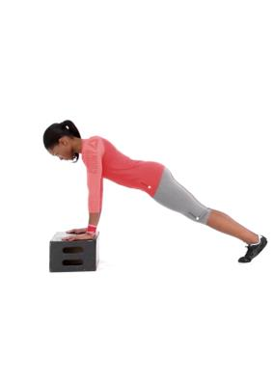

1st time here: Shoulder Combo –12 Side Lateral Raises, 12 Front Lateral Raises, 30 seconds Steering Wheel

2nd time here: same task but increase weight

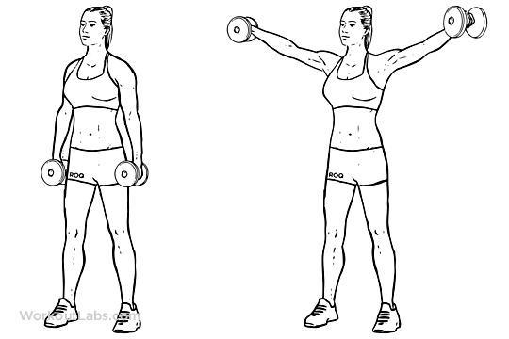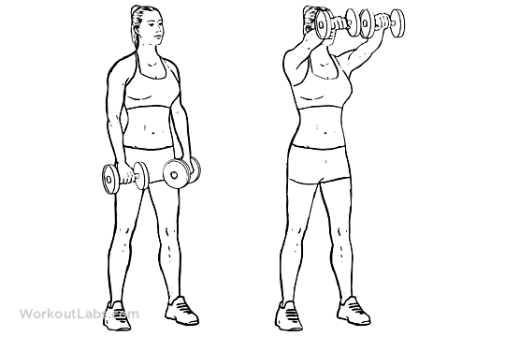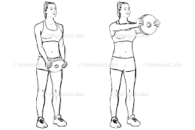

## Station 4: Muscular Strength

Lower Body Circuit: Do Each exercise without rest (8-10 reps of heaviest weight). Rest for 30 seconds. Do circuit 2 more times.

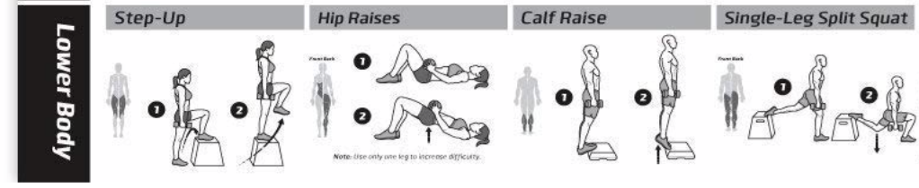 

Total Body Circuit: Pick 3 of the 5 exercises. Do the 3 exercises without rest (8-10 reps of your heaviest weight). Rest 30 seconds. Do circuit 2 more times.

2nd time here: do the same thing but choose exercises you haven’t done

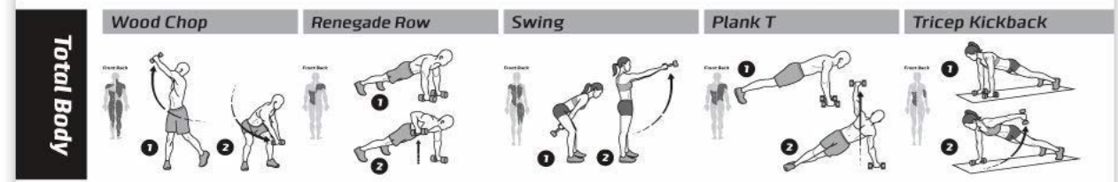

## Station 5: Muscular Strength

Upper Body Circuit: Pick 3 of the 5 exercises. Do the 3 exercises without rest (8-10 reps of your heaviest weight). Rest 30 seconds. Do circuit 2 more times.

2nd time here: choose exercises you haven’t done

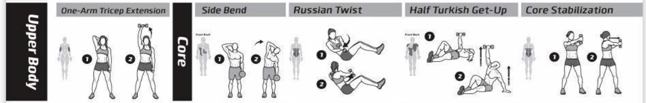

Lower Body Circuit: Pick 3 of the 5 exercises. Do the 3 exercises without rest (8-10 reps of your heaviest weight). Rest 30 seconds. Do circuit 2 more times.

2nd time here: choose exercises you haven’t done.

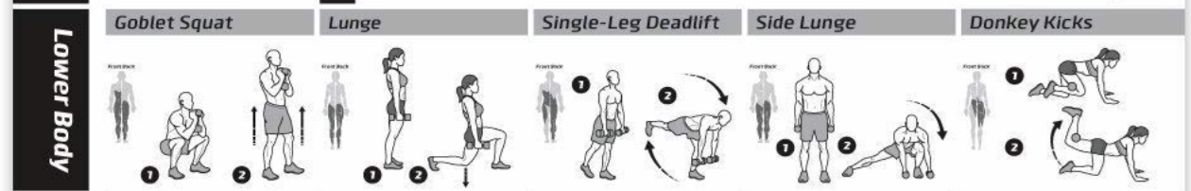

## Station 6: Muscular Strength

*You may have a 20 second rest in between exercises. If 1st time here do circuit once. If 2nd time here, do circuit 2x.*

Flip Tire for 1 Minute

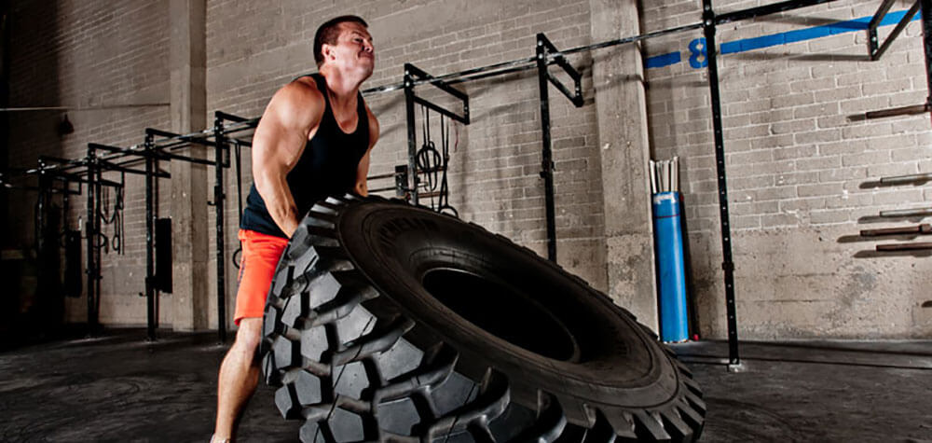

Medicine Ball Slams: Throw medicine ball as hard as you can at the ground from above head. Pick back up and repeat for 1 Minute.

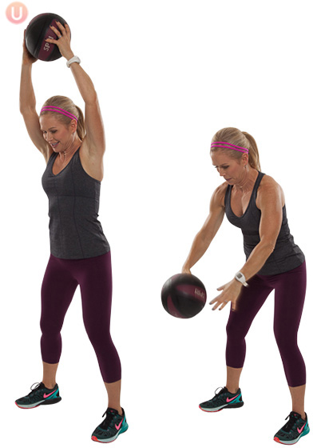

Throw Medicine ball up at the wall and squat while catching. Repeat for 1 Minute.



## Station 7: Muscular Endurance

Perform the following exercises as a complete circuit. Take 1-minute rest at the end. Do this circuit a total of 3 times.

15 Mountain Climbers

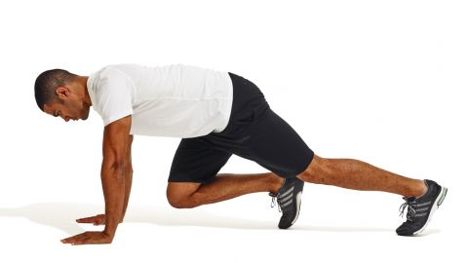

Suicides (There & Back to designated cones)

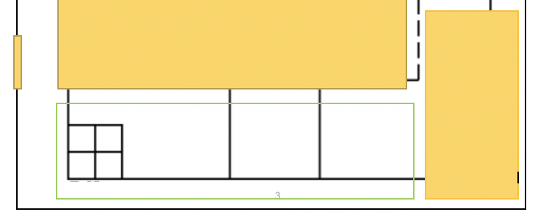

10 Frog Jumps to complete the circuit once done suicides.

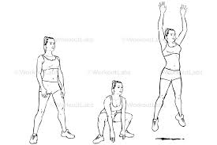

## Estimated Time to complete each station

Station 1: 5 Minutes

Station 2: 5 Minutes

Station 3: 4-5 Minutes

Station 4: 10-12 Minutes

Station 5: 10-12 Minutes

Station 6: 4-5 Minutes

Station 7: 10 Minutes

Challenge zone: 10 - 15 minutes

Students may not get to every station.

## Challenge Zone

Students will combine 2 teams into one (4 teams become 2). The must sprint there and back, then army crawl under the blue matts. Then do 1-foot jumps over the orange hurdles, then both partners must get their object into the bucket. After they must return wheelbarrowing their partner and tag the next person to go.

