big idea  Students will demonstrate their ability to apply nutrition knowledge and living skills to make reasoned decisions and take appropriate actions relating to their personal health and well-being. | topic Healthy Living, Strand C: Nutrition  Teacher Ms. Nyentap, Ms. Cessford, & Ms. Littlemore  Grade PPL???, 20 Students
Key learning(s) | TIMES | EQUIPMENT
Review concepts of nutrition learned throughout the semester (e.g., macronutrients, micronutrients, food labels, Canada’s Food Guide, diets, …) | Activity 1: __ minutes  Activity 2: __ minutes  Activity 3: 20 minutes | ??
activity #1 lesson objectives | activity #2 lesson objectives | Activity #3 Lesson objectives | CLOSING/ EXIT
List curriculum related and general lesson objectives | List curriculum related and general lesson objectives | - Students will demonstrate their knowledge of healthy eating practices in relation to their personal nutritional requirements so that they can eventually prepare healthy meal plans.  - Students will understand and be able to list examples of macro- and micro-nutrients and develop food label literacy so they can avoid the common pitfalls of fad dieting.  - Students will sustain physical activity while reviewing nutrition concepts. | - Determine the winner of activity #3.  - Discuss some of the curriculum stuff… concepts reviewed??  - Homework would be using the sheet to review concepts for a test.
Activity #1 | ACTIVITY #2 | Snakes and ladders Nutrition edition | CLOSING (Teacher talk)
 |  | Students will play an active board game called Snakes and Ladders Nutrition Edition. Cones will be spread out in rows containing nutrition pop quiz cards about nutrition labels, fad diets, protein, carbohydrates, fat, or micronutrients. Agility ladders and skipping ropes will determine if players are knocked back a couple spaces or get to advance.  Students play in pairs and begin on either end of the board game. They will use a dice to determine their initial position. When teams get to a cone, it will contain a question card and an exercise on it. To move on teams must record their answer on their sheet. Winner number one is the first to get to the end. Winner number two is the first to get the most correct answers on their sheet.  Inclusive Adaptations: Players can choose to do a different exercise that works the same body area if they can’t do the one on the card. Players can put their hand up for a helpful hint.  Adaptations: 4 students are chosen as experts and hold the answer key. They get to give hints to their classmates with a determined cost 9 (e.g., 5 push-ups).  Set-up: ¼ of the gym to begin and set up the rest as the second game ends/ explanation is given.  Equipment: 40 – 50 cones, 8 agility ladders, 10-15 skipping ropes, question cards, 5 answer keys.  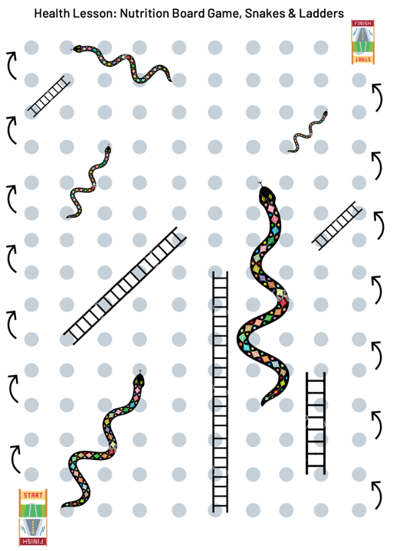 | This lesson was inspired by the idea of having an open Physical Education split grade level class (e.g., mix between grade 10s, 11s, and 12s). The lesson reviewed very fundamental and useful nutrition concepts. This lesson can be modified to hit all grade levels because it hits multiple curricular concepts in Strand C of the healthy living unit. This lesson does offer topics not mentioned in the curriculum which is an added benefit for the students as the curriculum is not a complete document of what students commonly see in their lives.
Learning prompts | LEARNING PROMPTS | LEARNING PROMPTS
Enter your vocabulary #1 words here | Enter your vocabulary #2 words here | - Students may choose to do a different exercise that targets the same body area  - Students may ask for a hint.  - Specific prompts towards answers will be determined at the time of a student asking a question.
Assessment: Assessment as learning in preparation for formative assessment (e.g., test, health magazine, or creation of healthy meal plan)  Teaching Style: | Assessment: Assessment as learning in preparation for formative assessment (e.g., test, health magazine, or creation of healthy meal plan)  Teaching Style: | Assessment: Assessment as learning in preparation for formative assessment (e.g., test, health magazine, or creation of healthy meal plan)  Teaching Style: Facilitator, Self-Check | SAFETY/ DIVERSITY CONSIDERATIONS:  - Refer to OPHEAs Safety Considerations  - Students with exceptionalities: …  - Students with cultural/linguistic differences: ….
Curriculum Links
Living Skills
Personal Skills 1.1 use self-awareness and self-monitoring skills to help them understand their strengths and needs, recognize sources of stress, take responsibility for their actions, and monitor their own progress as they participate in physical activities, develop movement competence,
and acquire knowledge and skills related to healthy living (e.g., Active Living: explain how knowing themselves – their likes, dislikes, strengths, and abilities – can contribute to their enjoyment of being active and support their participation in physical activity; Movement Competence: assess their technique when performing manipulation skills, such as sending, receiving, or retaining, to determine what adjustments need to be made to improve these skills; Healthy Living: describe the importance of understanding their personal strengths and values and using this understanding to guide them in making thoughtful decisions about their health)
Critical and Creative Thinking 1.5 use a range of critical and creative thinking skills and processes to assist them in making connections, planning and setting goals, analysing and solving problems, making decisions, and evaluating their choices in connection with learning in health and physical education (e.g., Active Living: use self-assessment information to identify adjustments that may be necessary in their fitness plans; Movement Competence: explain how the ability to apply movement skills, concepts, and strategies affects their movement competence and confidence and encourages their lifelong participation in physical activity; Healthy Living: describe how current dietary trends could influence their food choices, and explain the implications of these choices for healthy development
and active living)
GRADE 9, PPL10
C2. demonstrate the ability to apply health knowledge and living skills to make reasoned decisions and take appropriate actions relating to their personal health and well-being
C2.1 apply their knowledge of basic nutrition principles and healthy eating practices (e.g., relating food intake to activity level, ensuring their diet includes foods from all food groups in Canada’s Food Guide, using healthy preparation methods) to develop a healthy eating plan [PS, CT]
GRADE 10, PPL20
C2. demonstrate the ability to apply health knowledge and living skills to make reasoned decisions and take appropriate actions relating to their personal health and well-being
C2.2 assess the nutritional implications of a variety of dietary choices, including those reflecting current dietary trends, and explain how they can make personal choices that will provide the nutritional requirements for a healthy, active life [PS, CT]
GRADE 11, PPL30
C1. demonstrate an understanding of factors that contribute to healthy development
C1.1 describe the impact of various diseases and health conditions (e.g., Crohn’s disease, celiac disease, diabetes, cancer, anemia, allergies and food sensitivities, vitamin deficiency) on nutrient requirements, food choices, and meal planning
GRADE 11, PPZ3C
A1. explain how personal factors and individual health practices or behaviours influence personal health;
A1.3 explain how personal health practices, health knowledge, and healthy behaviours and attitudes contribute to the protection and improvement of an individual’s health
GRADE 12, PPL40
C2. demonstrate the ability to apply health knowledge and living skills to make reasoned decisions and take appropriate actions relating to their personal health and well-being;
C2.1 demonstrate the ability to make healthy eating decisions that take into account their personal requirements and resources (e.g., nutritional needs, personal likes, ethical and environmental values, budget, time available to shop and cook, access to different kinds of foods) in a variety of situations that they may encounter now and in the future (e.g., camping, living on their own, sharing accommodations) [PS, CT]
C3. demonstrate the ability to make connections that relate to health and well-being – how their choices and behaviours affect both themselves and others, and how factors in the world around them affect their own and others’ health and well-being.
C3.1 assess the food requirements and available food choices of people in a variety of life situations (e.g., the elderly, children, people with chronic diseases, women who are pregnant, families with low in- come, residents of remote northern communities, urban residents living in “food deserts” without ready access to fresh and local foods, shift workers, workers in sedentary occupations, individuals training to be elite athletes), and describe the options available to them for maintaining a healthy diet [CT]

