Lesson Plan: Health and Physical Education HIIT Training
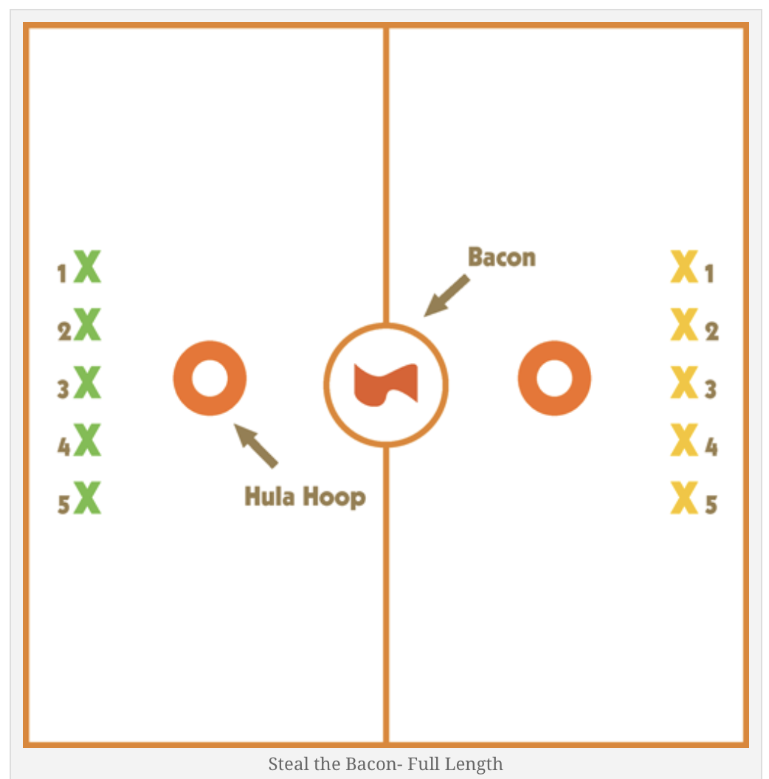
WARM-UP: Steal the Bacon (10 Minutes)
Both teams begin laying face down on their bellies. When their number is called, they sprint to steal the bacon from the middle hoop. Then who ever retrieves it first tries to put it in the other team’s hoop. The other player who did not get to the bacon quick enough becomes a tagger. If the player is tagged, the bacon is dropped on the spot. Two new players are called up to continue the game.

MAIN SET: Fitness Bootcamp Workout
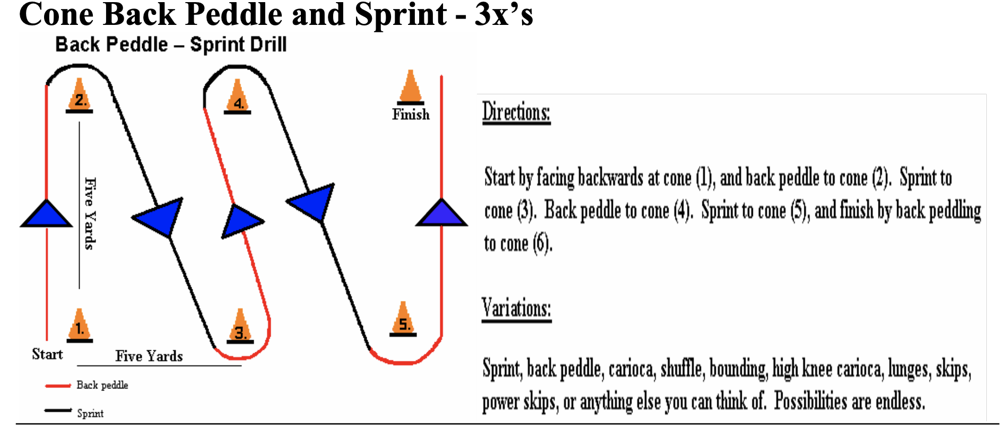 | 5 minutes continuous  Sprint & back pedal. Walk back to beginning.  Cardiovascular Fitness
Switch & 1-minute Rest
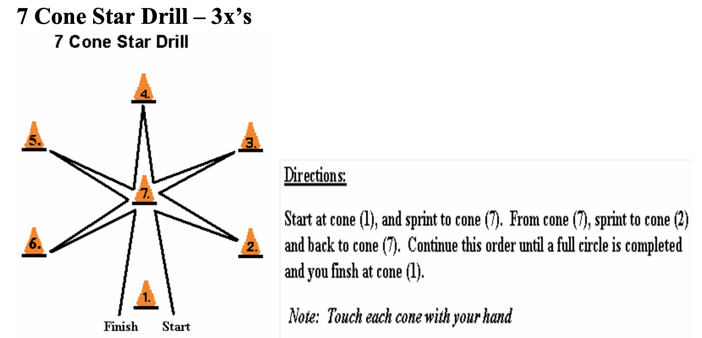 | 5 minutes continuous  Sprint to each cone to make the shape of a star.  Cardiovascular Fitness
Water Break & Set-Up (3 Minutes)
7 Stations (Rows) and 30-45 seconds at each station, 15-30 seconds rest/ transition time. Complete 1-2 times.
Jump Squats | 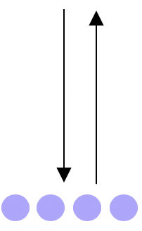
Push-ups
Towel Push
Mountain Climbers
Burpees
Walking lunges
Rope Slams & Rest/Water Station (Extra Students)

COOL-DOWN: Stretching/Flexibility Circle
- What components of physical/ health-related fitness were developed today?
  - CV endurance, muscular strength, flexibility, speed, agility.
- What sports/ physical activities might you apply this conditioning drill to?
- What life skill might you draw from today?
  - Perseverance, effort, doing something not as fun for the long-term gain. Sometimes you need to grind and put in the work to see the benefits in other areas of life.

***If we have time students can pick a sport that they would like to play for the remainder of the class.

Inclusive Adaptation
WARM-UP:
- Attempt the bacon game as a group, if not then do the following below…
- Sprint/ Run to the other side of the gym to grab a ball, run back and put it in the bucket.
- Modified basketball shooting with foam balls and hoops on the nets.

MAIN SET: Fitness Bootcamp Workout
5 minutes continuous
Run & back pedal. Walk back to beginning.

Students could perform this at a slower pace while the other students are doing the fitness station on the opposite side of the gym.

Cardiovascular Fitness
Water Break & Set-Up (3 Minutes)
Squat (use partner if needed) | Perform 3 sets of 30 seconds/ adjust time if needed. Do as a group.  Muscular Endurance
Plank
Jumping Jacks

COOL-DOWN: Stretching/Flexibility Circle
- All together as a class.

